Test board Architecture and Implementation for neuron hardware accelerator engine

Git repository

Tel Aviv University
Electrical Engineering Final Project 2024-2025

Version 0.9
14.06.2025

Yuval Desalto
Ariel Richter

Table of Contents

Overview 3
Theoretical Background 4
Requirements Definition 5
Performance Requirements 5
Validation Requirements 6
Top Block Diagram 8
Pre-Silicon Validation (FPGA-Based Testing – RTL Simulation) 9
Post-Silicon Validation (Fabricated DUT Testing – Real Hardware Validation) 9
Pre silicone 11
FPGA and DUT Integration Architecture 11
Components and Signals of FPGA-DUT integration 12
Signals and data transfer Between Subsystems 13
Data Bus Width and Multi-Cycle Transfers 13
Test environment 14
Test environment Components and Signals 15
Workflow of the Test Environment 17
Test environment RTL System Overview 19
Generator Diagram 20
Components and Signals of the Generator 20
Generator Workflow 21
Validator Diagram 21
Components and Signals of the Validator 22
Validator Workflow 23
DUT Block Diagram 24
DUT Components and Signals 24
DUT Workflow 27
MAC Diagram 29
Components and Workflow of MAC unit 29
MAC Workflow 30
System Workflow: End-to-End Testing Process 31
Step-by-Step Execution of the Testing Workflow 31
On-Chip Memory Structure and Test Format 35
Managing Button Bounce in the Reset Mechanism 38
Methodology: 38
How This Solves the Problem? 39
Post silicone 40
Hardware Setup for Post-Silicon Validation 40
Pin Placement 40
The diagram below shows the final planned pin placement for the DUT 40
Pinout Description 41
System-Level Schematic: DUT Integration and Power Routing 41
Appendix 43

Overview
The test board architecture is a key component of the testing framework for the MAC core, which serves as the Device Under Test (DUT) in this project. This architecture is designed to enable functional validation, performance evaluation, and reliability testing of the DUT during the pre-silicon validation and initial hardware testing stages. It provides a structured and modular approach to managing data flow, control signals, and test scenarios to ensure the MAC core functions correctly under various conditions.
At the center of the architecture is the FPGA, which acts as the primary platform for running test cases and simulating real-world scenarios. The FPGA includes buffers for data input and output, comparators for result validation, and a control unit that manages the testing process. This design ensures proper data communication between the FPGA and the DUT while enabling precise control of test parameters.
The test board integrates with external controllers or PCs to provide additional computational resources and manage data logging and analysis. This integration enhances flexibility and scalability, allowing the architecture to support different testing stages and future system requirements.
The architecture is built with modularity in mind, allowing individual functional blocks to be developed, tested, and optimized independently. This ensures that the testing system remains adaptable and capable of meeting evolving project needs while maintaining the accuracy and efficiency necessary for validating advanced semiconductor devices.

Theoretical Background

Hardware testing systems (Test Boards) are a critical component in the development and verification of advanced chips, particularly in projects based on deep learning principles and neural networks. This project focuses on developing a dedicated Test Board for testing a computational accelerator (MAC Core) based on the perceptron model. Designing and building such a system requires a deep understanding of the perceptron structure, data processing methodologies, and FPGA-based hardware verification. FPGA (Field Programmable Gate Array) platforms are central to this process, serving as the primary testing environment. Their reconfigurable architecture allows for the implementation of custom test benches that manage data input, output, and real-time validation of the DUT. This hardware-based approach ensures precise timing analysis, real-time error detection, and the ability to test under hardware-specific conditions, offering significant advantages over traditional software simulations. By leveraging FPGA technology, the system enables comprehensive validation, ensuring early detection of functional and integration issues while supporting a reliable development process.
A key aspect of the computational accelerator being tested is its reliance on the perceptron model, a foundational concept in machine learning and neural networks. The perceptron’s role and functionality are explained below to provide context for the DUT’s operation.

The Perceptron Model
The perceptron is a foundational concept in machine learning, mimicking the behavior of a single neuron in a neural network. It operates by performing a linear combination of input values, weighted by their respective coefficients, and adding a bias term. Mathematically, this can be expressed as:
$$y=\sum_{i=1}^{n}{w_{i}∙x_{i}+b}$$
where $w_{i}$ are the weights, $x_{i}$ are the inputs, and b is the bias term.
The perceptron’s output is determined by an activation function, which applies a threshold to the result of the linear summation. The function is defined as:
$$y= \left\{\begin{aligned}1 ;if y≥Threshold \\ 0 ; otherwise \end{aligned}\right.$$
In this project, the perceptron serves as the central computational unit within the MAC Core. Its purpose is to process input data efficiently, producing binary outputs that indicate whether certain conditions are met, such as recognizing patterns or calculating results in line with predefined thresholds.

Requirements Definition
The Test Board is designed to validate the functionality and performance of the computational accelerator (MAC Core), serving as the Device Under Test (DUT). The system requirements are defined to ensure reliable operation, compatibility with the FPGA platform, and the ability to achieve high testing coverage with minimal latency. These requirements encompass functional, performance, and validation metrics, ensuring the system meets the demands of pre-silicon and hardware-based testing stages.

Performance Requirements
- Clock Frequency:
The Test Board must operate at a clock frequency of 50 MHz. This frequency was selected based on the DE10-Lite FPGA’s operational specifications, ensuring compatibility with the clock management resources and the overall timing constraints of the board. The DE10-Lite supports clock frequencies within this range while maintaining stable and reliable operation. Operating at this frequency ensures that the design meets the timing requirements for accurate data processing and synchronization with the Device Under Test (DUT). This value was specifically chosen to optimize performance while ensuring the stability and reliability of the system under typical operating conditions.
- FPGA Resource Utilization:
The Test Board must limit its utilization to 50% of the FPGA’s available logic resources. This limitation was established to ensure that sufficient headroom remains for future development, debugging, or modifications that may arise as the project progresses. The DE10-Lite FPGA, equipped with 50,000 Logic Elements (LEs), is designed to accommodate designs of moderate complexity. By capping the utilization at 50%, we can prevent potential routing congestion and maintain timing stability across the design. This conservative allocation also ensures that any unforeseen requirements or features can be integrated into the system without requiring significant rework or impacting the system's performance.
- Power Consumption:
The Test Board must operate with a power consumption limit of 5W. This value was determined based on the specific usage capabilities of the DE10-Lite FPGA for our implementation. According to the DE10-Lite user manual, the power delivery system of the board is capable of reliably supplying this level of power, which includes both static (idle) and dynamic (operational) power consumption. By adhering to this limit, we ensure that the FPGA operates within its thermal and electrical constraints, avoiding overheating or power delivery issues. Additionally, maintaining this power limit aligns with efficient energy use and ensures that the board can support stable, long-term operation under typical conditions for our project requirements.
These requirements were carefully defined to balance the FPGA’s capabilities with the needs of the project, providing a robust foundation for current functionality while allowing room for future development.

Validation Requirements
To ensure the correctness and reliability of the DUT, the validation process is divided into three key phases: pre-silicon simulation, pre-silicon RTL prototyping, and post-silicon validation. Each phase targets different aspects of verification, from logical correctness to real-world system behavior. Additionally, real-time error reporting is an essential feature that supports debugging and validation across all stages but is not considered a separate validation phase.

Pre-Silicon Simulation

Pre-silicon simulation is the first stage of validation, where the DUT is tested in a software-based simulation environment. This phase focuses on verifying the logical correctness of the DUT before synthesis. Functional simulations are conducted at the RTL level to ensure that the DUT behaves as expected under different input scenarios. This process allows early detection of logical errors, misalignment with specifications, and potential inefficiencies in the design.

Pre-Silicon RTL Prototyping
To bridge the gap between simulation and real hardware testing, FPGA-based prototyping is used at the RTL level. The Test Board must enable the DUT to run on an FPGA platform, allowing for more accurate performance analysis, early debugging, and testing under real-world conditions. Unlike simulations, FPGA-based validation allows the design to run in actual hardware, exposing potential timing-related issues, memory access conflicts, and interface mismatches that may not appear in purely software-based simulations.

Post-Silicon Validation
Once the DUT has been fabricated or integrated into the FPGA platform, post-silicon validation is performed. This stage involves real-time functional and performance testing to identify any remaining issues that were not detected in pre-silicon phases. The system must support extensive real-time testing, including stress testing, functional corner cases, and hardware/software co-validation. The goal is to ensure that the implemented hardware meets all design specifications and operates correctly under realistic conditions.

Error Reporting (Applicable Across All Phases)

Error reporting is a fundamental aspect of the validation process. it plays a supporting role across pre-silicon simulation, RTL prototyping, and post-silicon validation. The Test Board must provide a robust real-time error detection and reporting mechanism, capturing details such as failed test cases, timing violations, and output mismatches. The error reporting system should be capable of detecting both transient and persistent errors, allowing efficiently trace back to root causes.

Flexibility and Scalability
The Test Board must support updates to the test environment, including modifications to test scenarios, additional DUT components, and changes in input/output configurations. This ensures adaptability to evolving project requirements and future scalability.

Top Block Diagram

The top block diagram represents the overall architecture of the project, structured into two distinct testing phases: pre-silicon validation and post-silicon validation. These phases ensure a comprehensive verification process, starting from RTL-level simulations to final hardware validation. The system integrates an FPGA-based test environment, an external DUT board for post-silicon testing, and a PC/controller, allowing for seamless data communication and evaluation of the MAC core at different development stages. This architecture provides a flexible and scalable testing framework, enabling precise debugging, performance analysis, and functionality verification across both stages.
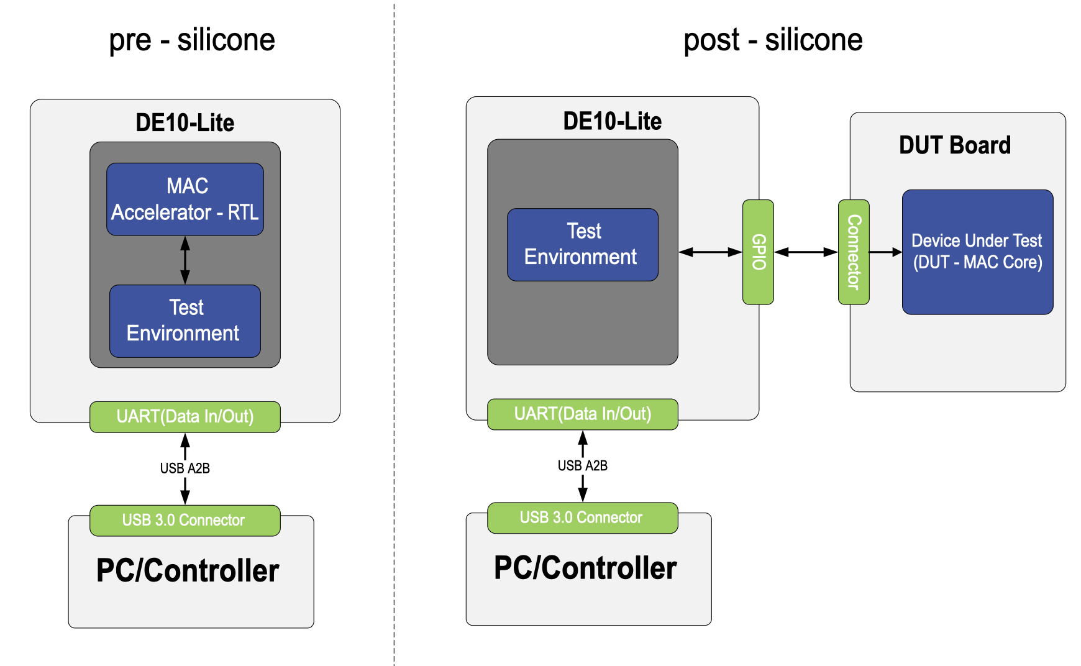
Figure 1 – Pre silicone and Post silicone Top Block Diagrams

Pre-Silicon Validation (FPGA-Based Testing – RTL Simulation)
During the pre-silicon phase, the MAC core is tested using an FPGA-based prototype before fabrication. This stage focuses on RTL verification and functional testing.
- The MAC core (RTL) is synthesized and implemented inside the DE10-Lite FPGA, along with the test environment.
- The test environment is responsible for generating input stimuli, handling execution, and validating outputs within the FPGA.
- Data is transferred between the PC/controller and FPGA via a UART interface, allowing test execution and real-time debugging.
- The PC/controller manages test execution, sending test vectors and analyzing results to ensure correctness before hardware fabrication.
- This stage helps identify logical errors, performance bottlenecks, and design flaws in a fully controlled simulation environment.

Post-Silicon Validation (Fabricated DUT Testing – Real Hardware Validation)
Once the MAC core has been fabricated into a physical chip, testing transitions to the post-silicon phase. This phase ensures that the real hardware implementation operates as expected under real-world conditions. Unlike pre-silicon testing, the MAC core is no longer inside the FPGA but instead exists on a separate DUT board, requiring external validation.
- The DE10-Lite FPGA now functions as a test environment, generating test stimuli and validating outputs received from the fabricated MAC core on the DUT board.
- The DUT board contains the fabricated MAC core, which processes the test inputs and produces outputs for verification.
- Data transfer between the FPGA and DUT board occurs through a GPIO connector, ensuring correct signal exchange between the test system and the DUT.
- The PC/controller remains the central management unit, retrieving results from the FPGA and analyzing the DUT's performance.
- This stage helps identify hardware-related issues, fabrication defects, timing mismatches, and integration challenges that may not have been detected during pre-silicon simulation.

PC/Controller
- Acts as the central control unit for managing and monitoring both pre-silicon and post-silicon testing processes.
- In pre-silicon testing, it sends test vectors to the FPGA and receives simulation results for analysis.
- In post-silicon testing, it retrieves test results from the DUT through the FPGA.
- Provides an interface for test configuration, execution, and real-time debugging.
- Uses USB 3.0 for high-speed data transfer between the PC and FPGA.

Interfaces
- UART (Data In/Out) – FPGA to PC
  - Enables bidirectional communication between the FPGA and the PC/controller.
  - Used in both pre-silicon and post-silicon testing for logging test results and sending control signals.
- GPIO Connector – FPGA to DUT Board
  - Handles data exchange between the FPGA test environment and the DUT.
  - Ensures proper transmission of test vectors and retrieval of processed results.
  - The exact connector type will depend on the final DUT board selection.

Pre silicone

FPGA and DUT Integration Architecture

The system architecture is based on an FPGA and integrates various components to create a comprehensive and self-contained testing environment. At its core, the architecture includes a host computer that communicates with the system via a USB Blaster interface, enabling efficient data transfer and FPGA programming. A communication pathway is established using the FT245 component, which converts USB signals to UART, and the MAX II CPLD, which manages UART communication and supports JTAG access. A clock generator provides synchronized clock signals to drive the entire system, ensuring timing consistency across all components.
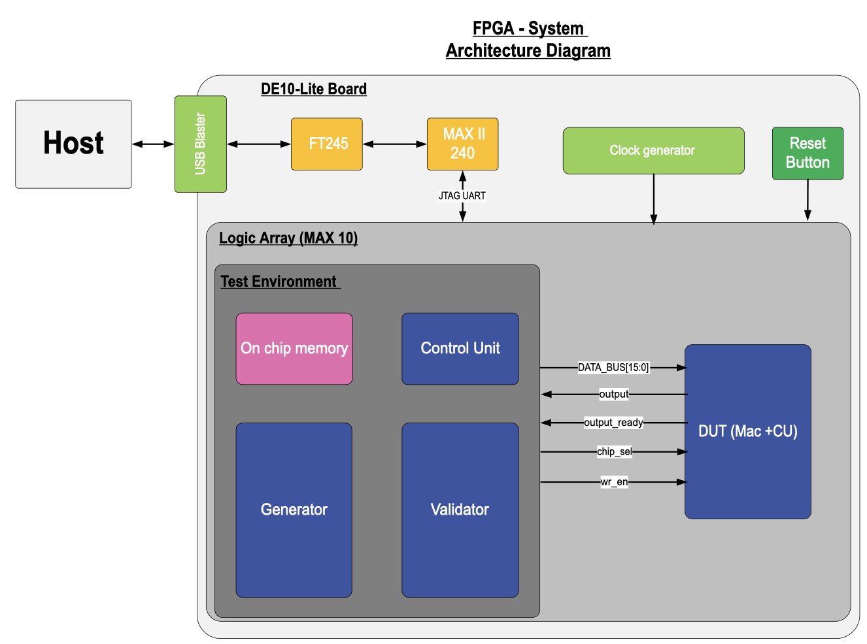
The FPGA, based on a MAX 10 logic array, hosts the full testing environment, including the control unit, test data generator, output validator, and on-chip memory blocks used to store input vectors and expected results. The Device Under Test (DUT) is integrated directly within the FPGA and interacts with these modules through a shared data bus and control signals. This architecture eliminates the need for external SDRAM, relying solely on low-latency on-chip memory to manage test data, which simplifies data flow and improves system reliability. The result is a compact, modular, and flexible testing platform capable of supporting complete validation cycles entirely within the FPGA.
Figure 2 - FPGA and DUT architecture

Components and Signals of FPGA-DUT integration

Host
The Host represents the external computer or controller used to communicate with the FPGA-based system. It sends commands, configurations, and data to the system via a USB Blaster interface.

USB Blaster
The USB Blaster serves as a bridge between the host computer and the FPGA system. It enables data transfer and programming of the FPGA through a USB interface.

FT245

The FT245 is a USB to UART bridge that converts USB signals into UART protocol. It facilitates efficient data flow between the host and the internal system, serving as a key component in communication.

MAX II (240)

The MAX II CPLD serves as a bridge between the UART interface and the system, managing communication and signal flow. It supports both UART and JTAG protocols for programming and debugging the FPGA.

Clock Generator

The clock generator provides the necessary clock signals to synchronize the operations of the system. It generates the DRAM_CLK signal, which is critical for operating the SDRAM and ensuring proper data transfer timing.

Logic Array (MAX 10)
The MAX 10 FPGA is the main programmable logic component in the system, hosting key subsystems:
- Test Environment:
  - Control Unit: Manages the testing process, synchronizes data flow, and coordinates communication with the DUT.
  - Generator: Sends input patterns (pixel-weight pairs) to the DUT.
  - Validator: Compares the DUT’s single-bit output against the expected result.
  - On-Chip Memory: Internal memory used to store test data, thresholds and expected results.
- Device Under Test (DUT):
  - Contains the MAC-based core and activation function.
  - Receives pixel-weight inputs and produces a single-bit binary output.

Reset Button
The Reset Button is a physical push button that reinitializes the system. When pressed, it issues a reset signal across all components, clearing internal states and memory contents and returning the system to a defined start state. This ensures a clean restart before running each test and is essential during development and debugging. The reset also triggers initialization of internal counters and logic without requiring external memory loading.

Signals and data transfer Between Subsystems
- DATA_BUS[15:0]: A 16-bit one directional bus used for data exchange between the test environment and the DUT.
- output: Carries the processed output data from the DUT to the test environment.
- output_ready: Indicates that the DUT has completed processing, and its output is ready for validation.
- chip_sel: Activates or enables the DUT during operations.
- wr_en: A write enable signal that initiates write operations within the DUT.
This diagram outlines an organized architecture where the host interfaces with the FPGA system via a USB link, data flows seamlessly through the various components, and the logic array performs testing and validation of the DUT with high precision.

Data Bus Width and Multi-Cycle Transfers
The system utilizes a 16-bit wide data bus, a design decision made to optimize resource efficiency since the majority of operations involve transferring 16-bit data. However, for operations requiring 22-bit data, such as loading the threshold value, data transfers are conducted over two consecutive clock cycles.
During two cycle operations:
- In the first clock cycle wr_en is up, bits 0-15 are written to the target destination.
- In the second clock cycle wr_en is up, bits 16-22 are written, ensuring complete data transfer.
This two-cycle approach efficiently supports operations requiring 22-bit data while aligning with the design decision to use a 16-bit data bus. The choice of a 16-bit bus was made because the majority of system operations inherently involve transferring 16-bit data, making this width optimal for resource utilization and performance. While threshold loading require handling 22-bit data, the two-cycle transfer mechanism ensures compatibility without compromising the system’s overall efficiency.

Test environment
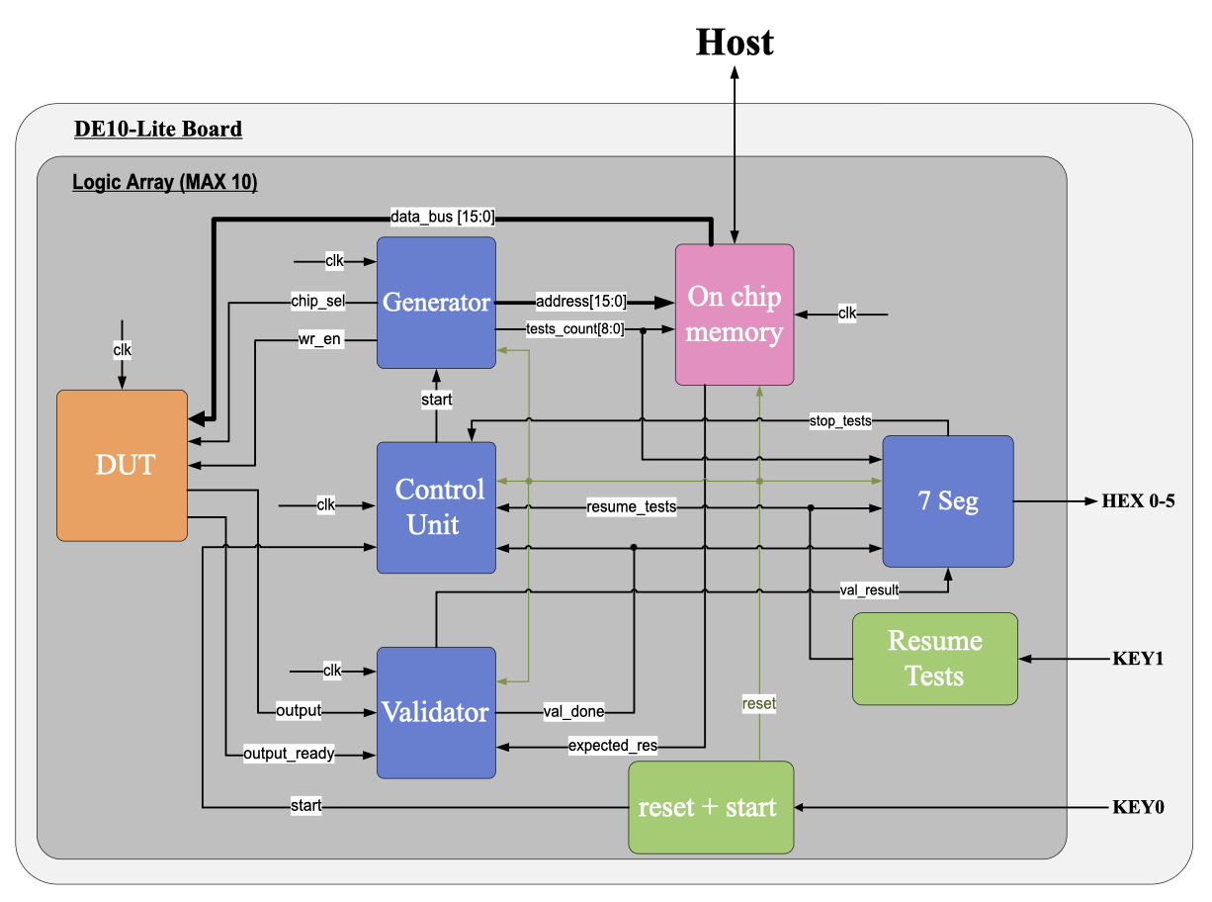
The test environment is designed to facilitate a controlled and efficient validation process for the DUT by streaming up to 500 complete test vectors, validating each output, and managing intermediate memory operations. It consists of key components: a generator that reads and sends 66 words per test (64 data plus 2 threshold) to the DUT, a validator that compares DUT outputs against expected results, an on-chip memory block that holds all 500 tests and their expected bits, a control unit that issues one cycle start pulses and coordinates test sequencing (including halting on two failures), a seven-segment display block that shows failing test indices, and a Resume Tests input (KEY1) to clear failures and resume execution. The system data transfer operates over a shared 16-bit data bus and uses a global clock to ensure precise synchronization and minimal latency.
Figure 3 – Test environment Diagram

Test environment Components and Signals

Control Unit
The Control Unit serves as the central coordinator for the test environment. It sequences test execution by issuing a one cycle start_run pulse for each new test, monitors validation completion, and halts further tests when a stop condition is asserted.
Signals and data:
- Inputs:
  - start: Triggers the start of a new test cycle.
  - clk: Synchronizes the operations across the test environment.
  - reset: Reset signal from pushbutton.
  - val_done: one-cycle pulse from Validator indicating that the current test’s comparison has finished.
  - stop_tests: level-high signal asserted by Seven-Segment Failures after two failures, which prevents any new test from starting.
  - stop_reset: one-cycle pulse from Resume Tests (KEY1) that clears the failure condition and re-enables test sequencing.
- Outputs:
  - start_run: Triggers operations in the generator.

Generator
The Generator reads each test’s 66 words from On-Chip Memory (64 data words + 2 threshold words) and streams them into the DUT one word per clock cycle. It tracks the current test number, gate writes to the DUT, and responds to val_done and stop_tests.
Signals and data:
- Inputs:
  - clk: Synchronizes the generator’s operations with the control unit.
  - reset: Resets the generator’s internal states.
  - start: Initiates data generation.
  - val_done: indicates validation process is done and we can lower chip_sel signal.
- Outputs:
- address_BUS[15:0]: Specifies the memory address for read from memory
- chip_sel: Selects the appropriate chip for data transfer (also responsible for resetting the chip components when chip_sel goes from low to high).
- wr_en: Enables writing test data to the DUT.
- tests_count[8:0]: index of the current test (0..499), used to compute the memory offset and drive Seven-Segment Failures.
  - Validator
The validator compares the DUT's output with expected result stored in memory. It ensures the DUT's functionality by signaling success or failure based on the comparison.
Signals and data:
- Inputs:
  - clk: Synchronizes the validator’s operations with the control unit.
  - reset: Resets the Validator’s internal states.
  - output_ready: Indicates that the DUT finished its calculation.
  - expected_output: Expected result read from memory.
  - output: 1-bit output from the DUT.
- Outputs:
- val_done: indicates validation process is done.
- result: 1-bit result indicating success or failure

  - On-Chip Memory
On-Chip Memory holds all 500 tests (66 words each) as well as a parallel array of 500 expected bits. Each read request is synchronous: when rd_en=1 and address_in is stable, data_out appears on the next clock edge. The expected bit is indexed by test_count.
Signals and data:
- Inputs:
  - address[15:0]: Specifies the memory location to place in the data bus.
  - clk: Synchronizes memory operations.
  - reset: resets on_chip_memory components .
  - test_count[8:0]: current test index, used to select expected_mem[test_count].
- Outputs:
  - data_BUS[15:0]: Provides test data to the DUT.
  - expected_res: expected result to the validator.
  - Reset and Start Module (KEY0)
This block debounces the physical KEY0 button and produces:
- An active-low reset pulse to all modules.
- A one-cycle start pulse that alerts the Control Unit to begin test #0.

Signals and data:
- Inputs:
- KEY0: Active-low pushbutton after debouncing from the board.
- Outputs:
- reset: Active-low system reset signal.
- start: One-cycle start pulse initiating the test.
  - Seven-Segment Failures Display
This block monitors the Validator’s val_done and result signals. On the first two failures (val_done=1 && result=0), it latches each failing test index and displays them on two separate sets of three 7-segment digits. After the second failure, it asserts stop_tests=1 to halt the Generator and Control Unit.
Signals and Data:
- Inputs:
  - clk: global clock.
  - reset: active-low reset.
  - val_done: one-cycle pulse from Validator.
  - result: 1-bit pass/fail from Validator.
  - test_count[8:0]: index of the test that just completed.
  - resume_rests: one-cycle pulse from Resume Tests (KEY1) to clear failures and deassert stop_tests.
- Outputs:
  - HEX0-2: three 7-segment outputs for the first failing test
  - HEX3-5: three 7-segment outputs for the second failing test
  - stop_tests: level-high when two failures have been recorded.
7. Resume Tests (KEY1)
This block uses the debounced physical KEY1 button and produces a one-cycle stop_reset pulse. When stop_reset=1, Seven-Segment Failures clears its failure count and deasserts stop_tests, allowing the Control Unit and Generator to resume from the tests.
Signals and Data:
- Input:
  - KEY1: physical pushbutton (active-low).
- Output:
  - stop_reset: one-cycle pulse that clears stop_tests and resets failure counters in Seven-Segment Failures.

Workflow of the Test Environment

Initialization Phase
After programming the FPGA, the system waits for a manual press of the reset button (KEY0). The Reset + Start module debounces the signal and issues an active-low reset to all components. When KEY0 is released, a one-cycle start pulse is sent to the Control Unit, triggering the beginning of the test sequence (test #0).

Test Execution Start
The Control Unit receives the start pulse, and immediately asserts a one-cycle start_run to the Generator (since stop_tests = 0). This transitions the Generator from GEN_IDLE to GEN_READ, beginning the first test’s data streaming.

Data Generation Phase
For each test index (0..499):
- The Generator pulls addr_counter from 0 to 65 (LOAD_DEPTH = 66).
- On each clock cycle, it updates address_BUS = LOAD_DEPTH * tests_count + addr_counter. The memory returns data_out on the next cycle.
- Simultaneously, the Generator asserts wr_en = 1 to latch the previously fetched word into the DUT.
- Then it increments addr_counter until 65, at which point it waits for val_done.

Processing Phase
As the DUT receives each of the 66 words, it processes them internally (multiplication, accumulation, threshold comparison). After consuming the final Threshold word of the test, the DUT asserts output_ready = 1 and places its single-bit result on mac_single_output.

Validation Phase
The Validator continuously monitors chip_sel and output_ready. When output_ready = 1, it latches both dut_single_output and expected_out (from memory indexed by tests_count), compares them, and produces: A one-cycle val_done = 1 and a 1-bit result (1 = pass, 0 = fail).
  - Failure Detection & Seven-Segment Display
The Seven-Segment Failures block monitors val_done and result:
- On the first val_done && (result == 0), it latches first_fail = tests_count and drives HEX0 -HEEX2 to display that index.
- On the second val_done && (result == 0), it latches second_fail = tests_count, drives HEX3 - HEX-5 and asserts stop_tests = 1.
- As soon as stop_tests = 1, the Generator stops issuing new rd_en (its GEN_IDLE condition requires !stop_tests), and the Control Unit stops issuing start_run.

  - Idle / Halt Phase
After one failed test, the system does not pause; the Control Unit immediately issues a new start_run (since stop_tests = 0 after the first failure), and the Generator begins the next test.
Once two failures occur, stop_tests = 1, so the entire test loop is frozen. The Generator remains in GEN_IDLE, and the Control Unit will not produce further start_run pulses.
  - Resume Phase (KEY1)
Pressing the “Resume Tests” key (KEY1) causes a one-cycle stop_reset = 1. When Seven-Segment Failures sees stop_reset = 1, it clears fails = 0, deasserts stop_tests = 0, and blanks both 7-segment displays. Simultaneously, the Control Unit sees (start || val_done || stop_reset) && !stop_tests become true, so it issues a one-cycle start_run. The Generator resumes at the current tests_count, streaming the next test.

Test environment RTL System Overview
The following RTL diagram, automatically generated by the Quartus synthesis tool, provides a visual overview of the full system architecture as implemented on the FPGA. It illustrates the interconnections between all major components of the test environment, including the clock generator, debounce logic, control unit, generator, on-chip memory, DUT, and validator.
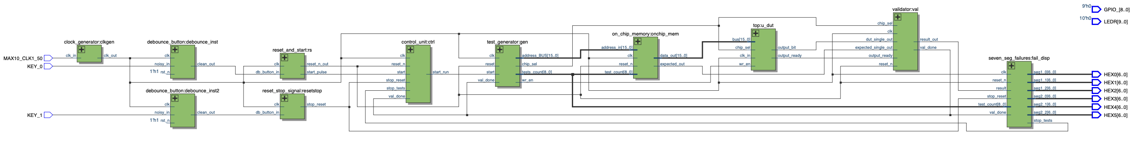
Figure 4 - RTL block diagram generated by Quartus

This RTL representation confirms that each module is instantiated and connected correctly, and allows verification of data/control signal flow prior to FPGA deployment.

Generator Diagram
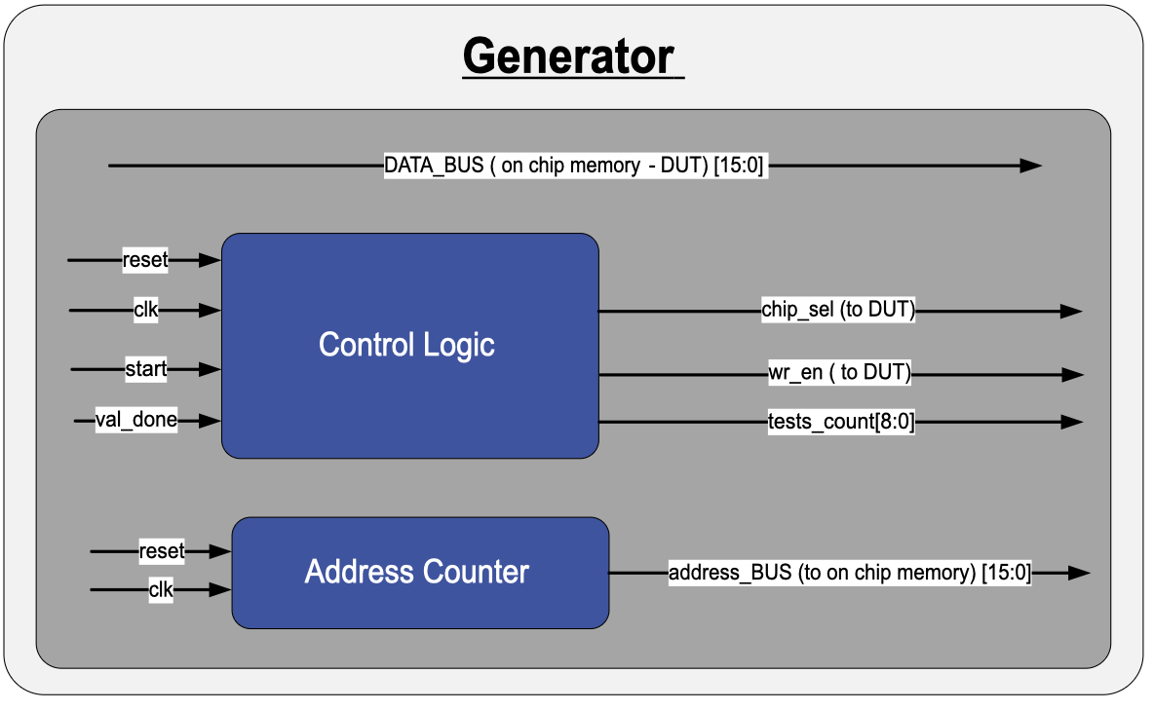
The generator is a key module in the FPGA-based testing environment. It streams up to 500 complete test vectors from on-chip memory into the Device Under Test (DUT), issuing synchronous read requests to memory and driving chip_sel and wr_en to the DUT under the control of a one-cycle start_run from the Control Unit (provided stop_tests is low). An internal address counter and tests_count index select each word (64 data + 2 threshold) for the current test. After the final threshold word, chip_sel remains asserted until a one-cycle val_done from the Validator, at which point the generator increments tests_count. If stop_tests is asserted (after two failures), the generator idles until a one-cycle stop_reset from KEY1 clears the halt condition.
Figure 5 - Generator Diagram

Components and Signals of the Generator

Components:
- Control Logic
  - Manages the overall operation of the generator.
  - Sends control signals to both the on chip memory and the DUT to ensure correct data transfer.
  - Responsible for asserting the required signals to the DUT, such as wr_en and chip_sel to enable data movement.
  - Receives val_done from the Validator and drives tests_count[8:0] to track the current test index.
- Address Counter
  - Generates sequential addresses for reading test data from the on-chip memory.
  - Advances the address on each clock cycle after receiving the start signal.
  - Operates in sync with the control logic to ensure that memory access is orderly and timed correctly.

Signals and data

Inputs:
- reset: Resets the generator to its initial state, clearing counters and control signals.
- clk: The clock signal used to synchronize the generator's operations with the system.
- start: A signal from the control unit that initiates the data transfer process.
- output_ready: received from DUT to give feedback about the duration of time that chip_sel needs to stay high.
- val_done: one-cycle pulse from the Validator indicating that the previous test’s comparison is complete.

Outputs:
- address_BUS[6:0]: Address for data from on-chip memory
- chip_sel: Chip select signal to enable the DUT for receiving data (needs to stay high until one cycle after output_ready is received).
- wr_en: Write enable signal to load the retrieved data into the DUT.
- tests_count[8:0]: current test index (0..499), used both by the memory and by Seven-Segment Failures.
Note: The data itself flows directly from the on-chip memory to the DUT via the DATA_BUS[15:0]. The generator does not drive or receive this bus directly.

Generator Workflow

Once the Control Unit drives start_run, the generator zeroes addr_counter and raises chip_sel to enable the DUT. On every clock edge, it updates the address as address_BUS = addr_counter + LOAD_DEPTH*tests_count. Because On-Chip Memory presents its word on data_out one cycle later, the generator then asserts wr_en exactly one cycle after entering the WRITE state, to latch the valid 16-bit word into the DUT. Meanwhile it leaves chip_sel high and increments addr_counter each cycle, cycling through all 66 words (64 data + 2 threshold). When the last threshold word has been written, the FSM enters WAIT_VAL, holds chip_sel asserted, and waits for the single-cycle val_done pulse from the Validator. As soon as val_done arrives, the generator deasserts chip_sel, increments tests_count, and if tests_count < TOTAL_TESTS, returns to IDLE to await the next start_run; otherwise, it stays in DONE.

Validator Diagram

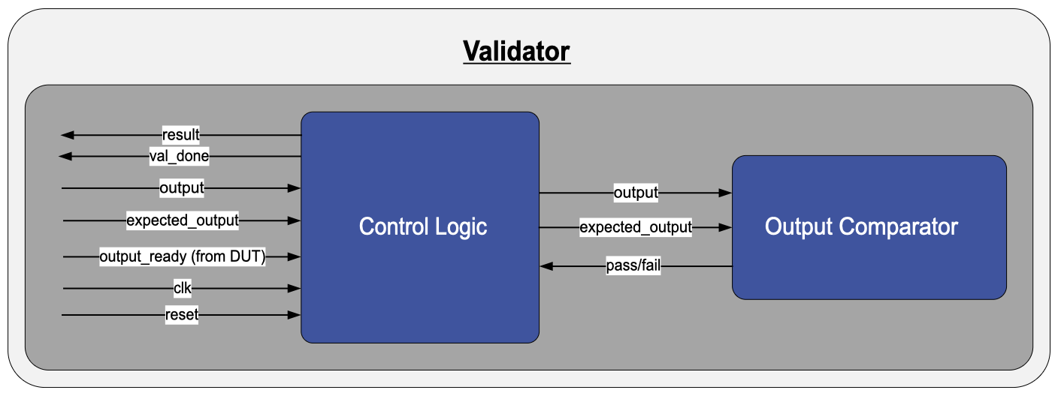
The validator is a critical component in the test environment, responsible for verifying the correctness of the DUT’s binary output. It compares the single-bit result generated by the DUT to the expected value stored in memory. The validator operates in real time: once the DUT signals output_ready, the validator performs the comparison and generates a pass/fail signal that is directly routed to LEDs on the board. This mechanism enables fast feedback and reliable identification of incorrect computations.
Figure 6 - Validator Diagram

Components and Signals of the Validator

Components-
- Control Logic
  - Coordinates the validation process based on system clock and reset.
  - Monitors the output_ready signal and triggers the comparison.
  - Asserts the val_done signal to notify the generator when validation is complete.
- Output Comparator
  - Receives both the actual DUT output and the expected result from memory.
  - Performs a bitwise comparison.
  - Generates a 1-bit pass/fail result indicating whether the DUT output is correct

Signals and data-

Inputs:
- reset: Resets the validator, clearing all internal states in the control logic.
- clk: Synchronizes the operations of the validator with the system clock.
- output_ready: Indicates that the DUT has finished processing, and its output is available for validation.
- output: The data output from the DUT that needs to be validated.
- expected_output: The pre-stored expected results fetched from memory for comparison.

Outputs:
- result: 1-bit signal indicating whether the DUT output matches the expected result.
- val_done: Signals that validation is complete and the generator can proceed.

Validator Workflow
Once the DUT finishes processing and asserts output_ready, the validator’s control logic initiates the comparison process. It receives the 1-bit output from the DUT and the corresponding expected output from the on-chip memory. These values are forwarded to the output comparator, which performs a direct comparison.
If the values match, the comparator asserts the pass/fail output accordingly (e.g., logic high for pass). The result is routed to the system’s LED indicators to give immediate visual feedback. After comparison, the validator asserts val_done, signaling that the system can return to idle or proceed to the next test.

DUT Block Diagram

This diagram illustrates the internal architecture of the DUT, which is designed to process pixel-weight pairs and produce final outputs for validation. The DUT integrates an IO block, control unit, input and weights memory blocks, a MAC unit, an activation function, and an output memory block. Each component operates in synchronization, with the control unit orchestrating data flow and processing across the pipeline.
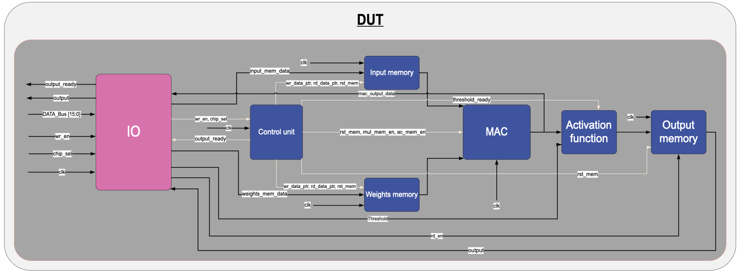
Figure 7 - DUT diagram

DUT Components and Signals

1. IO Block
The IO block serves as the main interface for data transfer between external systems and the DUT. It facilitates initialization by receiving pixel, weight, and threshold data, and provides real-time access to intermediate results and final outputs. The IO block ensures seamless communication with the DUT's internal components.
Inputs:
  - data_BUS[15:0]: Transfers input data (pixels, weights, and thresholds) from external systems to the DUT.
  - wr_en: Enables writing input data into the DUT’s memory.
  - chip_sel: Selects specific components or memory blocks for data transfer.
  - clk: The clock signal used to synchronize the generator's operations with the system.

Outputs:
  - output: Provides the processed final results to external systems.
  - output_ready: Indicates the completion of the DUT's processing pipeline and readiness of output data.

2. Control Unit
The control unit coordinates the operation of all subsystems within the DUT, including memory access, MAC unit activation, and threshold application in the activation function. It generates control signals to manage data flow and ensures that each component operates in proper synchronization.
Inputs:
  - clk: Synchronizes the DUT's operations.
  - wr_en: Enables writing input data into the DUT’s memory.
  - chip_sel: Selects specific components or memory blocks for data transfer.
Outputs:
  - wr_data_ptr: Specifies the address in memory for data writing.
  - rd_data_ptr: Specifies the address in memory for data reading.
  - mul_mem_en: Activates the MAC unit’s multiplication operation.
  - ac_mem_en: Enables the MAC unit’s accumulator to store intermediate results.
  - rst_mem: Resets the Output Memory, and Accumulator to their initial states before computation begins.
  - threshold_ready: Indicates readiness to sample and apply the threshold value.
  - output_ready: Signals that the DUT has finished processing.

3. Input Memory
The input memory stores pixel data received during initialization. During computation, it supplies pixel data to the MAC unit for processing.
Inputs:
  - wr_data_ptr: Specifies the memory address for writing pixel data.
  - rd_data_ptr: Specifies the memory address for reading pixel data during computation.
  - clk: Synchronizes memory operations.
  - rst_mem: Clears the memory contents before starting a new computation.

4. Weights Memory
The weights memory stores the weight values corresponding to the input pixels. These weights are retrieved during computation for processing by the MAC unit.
Input Signals:
  - wr_data_ptr: Specifies the memory address for writing weight data.
  - rd_data_ptr: Specifies the memory address for reading weight data during computation.
  - clk: Synchronizes memory operations.
  - rst_mem: Resets the memory contents before a new computation cycle.

5. MAC (Multiply-Accumulate) Unit
The MAC unit performs the core arithmetic operations, multiplying pixel data with weight values and accumulating the results. It operates under the control of the control unit and passes its final output to the activation function.
Inputs:
  - Pixel data: Received from the input memory.
  - Weight data: Received from the weights memory.
  - mul_mem_en: Enables the multiplication operation.
  - ac_mem_en: Enables the accumulation operation.
  - clk: Synchronizes the MAC operations with the system.
  - rst_mem: Resets the accumulator before starting a new computation.
Outputs:
  - mac_output_data: The accumulated result sent to the activation function.

6. Activation Function
The activation function applies a threshold to the accumulated result from the MAC unit, generating a binary output.
Inputs:
  - MAC_output: Data from the MAC unit to be processed.
  - threshold_ready: Indicates that the threshold value is ready to be applied.
  - threshold: The predefined threshold value used for comparison.
Outputs:
  - Processed data: Sent to the output memory for storage.

7. Output Memory
The output memory stores the processed data from the activation function. It serves as a buffer, allowing the IO block to retrieve results for external validation or further processing.
Inputs:
  - Data: Received from the activation function.
  - rst_mem: Resets memory for new computations.
  - clk: Synchronizes memory operations with the DUT.
  - rd_en: Enables reading data for external systems.
Outputs:
  - output: Sent to the IO block for external retrieval.

DUT Workflow
- Initialization Phase
  - The FSM within the control unit manages the initialization by orchestrating memory write operations.
  - Pixel data and weight values are transferred from the IO block to the input memory and weights memory using the wr_data_ptr signal.
  - The threshold value is also received from the IO block and stored in the threshold register within the activation function.
  - The rst_mem signal is asserted to reset all internal memories and prepare the system for a new computation cycle.
- Data Fetch Phase
  - The control unit issues the rd_data_ptr signal to sequentially read pixel data from the input memory and weight values from the weights memory.
  - The data is fed into the MAC unit in the correct order for computation, ensuring alignment between the pixel and weight pairs.
- Processing Phase
  - The MAC unit performs element-wise multiplication of pixel and weight pairs using its multiplier.
  - The results are zero-padded and passed to the accumulator via the adder to calculate a cumulative sum.
  - The control unit generates the mul_mem_en and ac_mem_en signals to enable the multiplication and accumulation processes, ensuring proper synchronization of operations.
- Thresholding Phase
  - After all pixel-weight pairs have been processed, the cumulative result from the MAC unit is sent to the activation function.
  - The threshold_ready signal is asserted, enabling the threshold register within the activation function to sample the threshold value from the data bus during the final cycle of computation.
  - The activation function compares the accumulated result with the stored threshold value and generates a binary output (1 or 0) based on whether the result meets or exceeds the threshold.
- Output Storage Phase
  - The binary output from the activation function is written to the output memory under the control of the FSM using the wr_en signal.
  - The output memory stores the final results, making them available for retrieval by external systems.
- Result Retrieval Phase
  - Once the computation is complete, the output_ready signal is asserted, signaling that the final processed results are available.
  - The IO block retrieves the output data from the output memory and sends it to external systems for validation or further use.
- Idle Phase
  - After all computations are completed and the result is retrieved, the control unit transitions the DUT into an idle state, preparing the system for the next operation cycle.

MAC Diagram

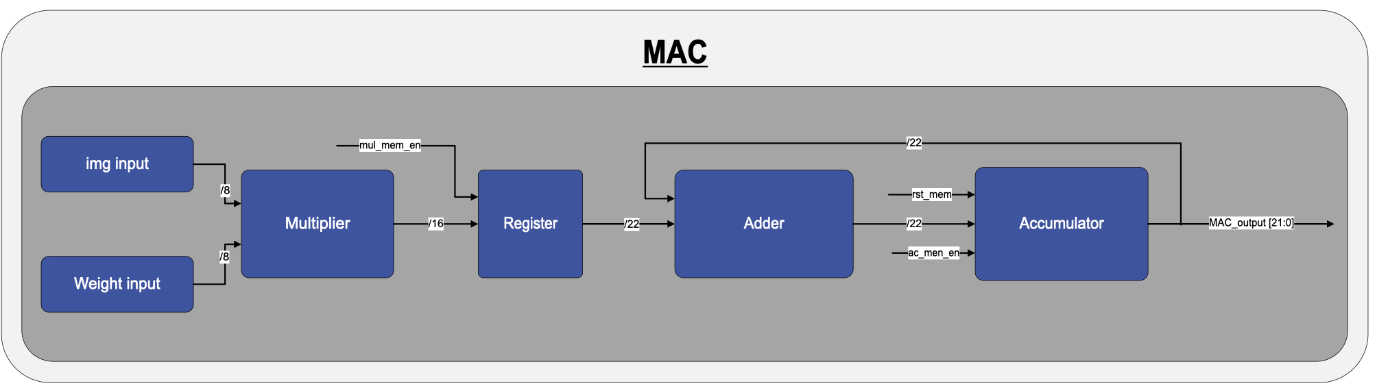
The MAC (Multiply-Accumulate) unit is a fundamental component within the DUT, responsible for executing the arithmetic operations required for processing pixel-weight pairs. This unit performs element-wise multiplication followed by accumulation of the results, which are then passed to subsequent processing stages. The MAC unit operates in a synchronized manner, ensuring that intermediate results are retained across multiple cycles, allowing for efficient and precise calculations.
Figure 8 - MAC diagram

Components and Workflow of MAC unit

Components:
- Multiplier
  - Receives input pixel and weight values, performing element-wise multiplication.
  - Outputs a 16-bit result, which is forwarded to the next stage.
- Register
  - Temporarily holds the multiplication result produced by the multiplier.
  - Facilitates stable data flow to the adder, synchronized with the system clock.
  - Applies zero-padding to the 16-bit multiplication result to match the 22-bit format required by the subsequent stages.
- Adder
  - Receives the multiplication result from the register and adds it to the current accumulated value from the accumulator.
  - Produces a 22-bit summation result for the accumulation stage.
- Accumulator
  - Stores the intermediate and final summation results.
  - Provides the current accumulated value to the adder for continuous summation.
  - Outputs the final accumulated result as a 22-bit value.

Control Signals
- mul_mem_en
  - Enables the register to store the multiplier’s output.
  - Ensures that the multiplication result is sampled and held for addition.
- ac_mem_en
  - Enables the accumulator to sample and store the intermediate summation result.
  - Facilitates the continuous accumulation process by updating the stored value after each addition.
- rst_mem
  - Resets the accumulator to its initial state, clearing any previous summation results.

MAC Workflow
- At the start of the computation cycle, the MAC unit receives pixel and weight values through the img input and Weight input ports.
- The multiplier performs element-wise multiplication of the inputs, generating a 16-bit result.
- The multiplication result is stored in the register, which stabilizes the data for the next computation step.
- The adder receives the multiplication result and adds it to the accumulated sum retrieved from the accumulator.
- The updated summation is stored in the accumulator, ensuring the retention of intermediate results across cycles.
- Once all pixel-weight pairs are processed, the final accumulated result is made available at the MAC_output port for further processing.

Output
The MAC unit generates a 22-bit accumulated result, which is made available at the MAC_output port. This result can be utilized for further stages, such as activation or threshold comparison. The real-time accessibility of the output also allows for monitoring and debugging during the computation process.
This structured and efficient workflow ensures precise processing of pixel-weight pairs and robust arithmetic operations within the DUT.

System Workflow: End-to-End Testing Process

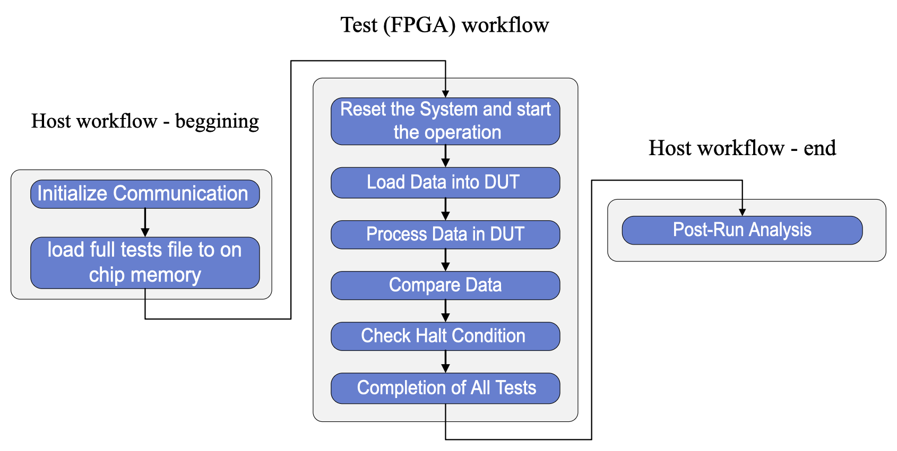
The system is designed to validate the Device Under Test (DUT) by executing predefined test cases, comparing each output against an expected result, and reporting success or failure via onboard LEDs. The workflow is divided into three coordinated stages: host-side preparation, FPGA-side test execution, and host-side post-processing.
Figure 9 – Full workflow diagram

Step-by-Step Execution of the Testing Workflow

Test Preparation on the Host (PC)
- A Python script generates 500 test cases, each containing:
  - 64 pixel-weight pairs (each 16-bit word packs one 8-bit pixel and one 8-bit weight)
  - Two 16-bit threshold words (LSW and MSW)
  - A 1-bit expected result (stored as a single bit in a 16-bit word, appended to the test’s data)
- The script concatenates all 500 tests into a single initialization file (MIF) for On-Chip Memory:
  - Total memory size = 500 tests × 66 words/test = 33 000 words
  - An “expected_mem” array of 500 bits is also generated in the same file.
- The host opens communication (e.g. via the Quartus Programmer or Qsys Control Panel) and downloads this MIF into the FPGA’s On-Chip Memory.
- Once the download completes, all 500 tests (inputs and expected bits) reside entirely in On-Chip Memory.

System Initialization
- The user presses KEY0 on the DE10-Lite board. This button is connected to the debounce module.
- KEY0 is debounced and drives a clean signal to the Reset + Start module. The reset+start module drives an active-low reset_n pulse to every block
- As soon as KEY0 is released, reset + Start produces a one-cycle, active-high start pulse into the Control Unit.
- At this moment:
  - tests_count is at 0 (the first test index)
  - stop_tests is 0 (no failures recorded yet)
  - All internal registers inside the modules are in their reset state.

Data Generation Phase
- Control Unit → Start_Run
  - Upon receiving the one-cycle start from Reset + Start, the Control Unit immediately asserts a one-cycle start_run to the Generator (provided stop_tests = 0).
- Generator Initialization
  - The Generator’s Control Logic sees start_run = 1 and tests_count = 0. It sets addr_counter = 0 and raises chip_sel = 1 to enable the DUT.
  - The internal 9-bit tests_count bus (0..499) remains stable at 0 until validation finishes.
- Sequential Memory Reads & DUT Writes
  - For each of the 66 words (addr_counter = 0..65):
    - The Generator computes the memory read address
    - On clock N: drive address_BUS = addr_counter + LOAD_DEPTH*tests_count (with chip_sel=1).
    - On clock N+1: when data_out from memory is valid, generator asserts wr_en=1 to latch the word.
    - The Generator then increments addr_counter += 1 (next word).
- This process repeats for all 66 addresses:
- Words 0..63 = 64 pixel-weight pairs
- Word 64 = threshold LSW
- Word 65 = threshold MSW
  - During the entire 66-word sequence, chip_sel remains high, marking that the DUT is actively receiving test #0.
- End of Test 0 Input
  - When addr_counter == 65, the Generator has fetched the final threshold word and performed one final wr_en.
  - It continues to hold chip_sel = 1 and transitions to a “Wait-for-Validation” substate.
  - No new rd_en or wr_en pulses occur until the Validator signals completion.

Processing Phase
- As each 16-bit word arrives (pixel + weight), the DUT’s internal MAC unit multiplies and accumulates the incoming values.
- After the final threshold word (word 65) is latched, the DUT completes its computation and applies the activation function (threshold compare).
- the DUT Drives its single-bit result onto mac_single_output and asserts output_ready = 1 for exactly one clock, indicating the result is valid.

Validation Process
- Detecting output_ready
  - The Validator monitors the DUT’s output_ready and the concurrent chip_sel (so that it knows which test index is active).
  - As soon as output_ready = 1 (one-cycle pulse), the FSM transitions to read both the latched dut_single_out (the DUT’s 1-bit output) and the latched expected_single_out (fetched earlier from On-Chip Memory at index tests_count)
- Comparing Actual vs. Expected
  - The Validator compares dut_single_out to expected_single_out.
  - If they match → result = 1 (pass); else → result = 0 (fail).
  - The Validator then asserts val_done = 1 for one cycle to notify the Generator (and Control Unit) that the comparison is complete.
6. Failure Detection & 7-Segment Update (Seven-Segment Failures)
- The Seven-Segment Failures block monitors val_done = 1 and the 1-bit result.
  - First Failure (val_done && result == 0 && fails == 0):
    - Record first_fail = tests_count.
    - Decode the decimal digits of first_fail (hundreds/tens/ones) and drive HEX 0-2 accordingly.
    - Increment fails to 1.
    - Keep stop_tests = 0 (still allow further tests).
  - Second Failure (val_done && result == 0 && fails == 1):
    - Record second_fail = tests_count.
    - Decode and drive HEX 3-5 for second_fail.
    - Increment fails to 2.
    - Assert stop_tests = 1 → halts the Generator and Control Unit from issuing new tests.
- If result == 1 (pass) or fails >= 2, no new changes to 7-segment or stop_tests occur in this cycle.

Advance or Halt (Generator & Control Unit)
- Generator Response
  - As soon as val_done = 1, the Generator:
    - Deasserts chip_sel = 0.
    - Increments tests_count += 1 (move to next test index).
  - Then checks two conditions:
    - If (tests_count < TOTAL_TESTS) && (stop_tests == 0), return to GEN_IDLE and immediately begin streaming the next test when the Control Unit issues a new start_run.
    - Otherwise (either tests_count == 500 or stop_tests == 1), move to GEN_DONE and don’t assert rd_en/wr_en again.
- Control Unit Response
  - Upon receiving one-cycle val_done = 1, the Control Unit will issue another one-cycle start_run (unless stop_tests == 1).
  - This creates a seamless chain of start_run → Generator reads 66 words → DUT/Validator → val_done → start_run for as many tests as possible.
  - If stop_tests == 1 (two failures), the Control Unit will refuse to issue any further start_run, leaving the Generator idle.

Resume Operation after Halt (KEY1)
- Once two failures have been recorded (stop_tests = 1), the user presses KEY1
- The Resume Tests block (connected to KEY1) generates the stop_reset = 1.
- Seven-Segment Failures sees stop_reset = 1 and It clears fails = 0, stop_tests = 0, and blanks both sets of HEX0-2 and HEX3-5.
- Simultaneously, the Control Unit sees (start || val_done || stop_reset) && !stop_tests. Because stop_reset = 1 and stop_tests was just cleared, it pulses start_run = 1 for one clock.
- The Generator picks up start_run (with its current tests_count - the next untested index, unchanged), sets addr_counter = 0, asserts chip_sel = 1, and resumes streaming test N+1 as before.

9. Completion of All 500 Tests
- This cycle (Generator → DUT → Validator → 7-Segment → possibly Halt → Resume) continues until tests_count reaches 500 (after test #499 completes).
- On the final iteration, after the Validator’s val_done for test #499:
  - The Generator increments tests_count to 500, then transitions to GEN_DONE (never reasserting any control signals).
  - The Control Unit does not issue further start_run (because tests_count == TOTAL_TESTS).
- At this point, all 500 tests have executed and been validated. The FPGA workflow halts permanently.

On-Chip Memory Structure and Test Format
The on-chip memory serves as the primary storage for all test-related data used during FPGA-based validation. It is implemented as an internal memory array inside the FPGA, with a fixed structure that supports efficient access by both the generator and the validator.

Memory Format and Layout
All 500 test cases are stored consecutively in a single linear block of memory. Each test case occupies exactly 66 consecutive sixteen‐bit words. The layout for test number N (where N = 0..499) is as follows:
- Pixel-Weight Pairs (64 words)
  - Each 16-bit word stores one 8-bit pixel and one 8-bit weight.
  - These values are paired sequentially in the format: {pixel, weight}.
  - Total: 64 words = 64 × 16 bits.
- Threshold Values (2 words)
  - A fixed 22-bit threshold is stored across two 16-bit words.
  - The first word contains the lower 16 bits of the threshold.
  - The second word contains the upper 6 bits, padded with leading zeros.
  - Total: 2 words = 32 bits used (with 10 unused bits in the second word).
- Expected Result (1 bit)
  - The expected binary classification result (0 or 1) for the test.
  - During validation, the Validator block indexes expected_mem[N] to retrieve the one-bit expected outcome for test N.
In total, because each test occupies exactly 66 sixteen-bit words, the entire data region spans addresses mem[0] through mem[32999].

Python-Based Test File Generation
A custom Python script creates exactly 500 test blocks in the correct order. For each test case it:
- Generates a pixel‐weight matrix and a valid 22-bit threshold.
- Computes the single‐bit expected output (1 if MAC result ≥ threshold, 0 otherwise).
- Packs each threshold into two sixteen‐bit words.
- Appends the expected bit into the expected_mem array.

The script then produces:
- A Memory Initialization File (MIF) that initializes mem[0..32999] with all 500 × 66 words in sequence and a separate initialization directive for expected_mem[0..499].
Once generated, the host loads those two arrays into on‐chip memory (for example via Quartus Control Panel or JTAG). After this load step, all test vectors and expected results reside locally in the FPGA, with zero further host interaction required at runtime.

Memory Access during testing
- Generator: issues rd_en and drives address[15:0] to read one sixteen bit word per cycle from mem. The offset increments 0..65 to stream all 66 words of test N.
- DUT: receives each sixteen‐bit word directly from data_out (the memory’s output bus) whenever rd_en=1, latching it under wr_en and chip_sel.
- Validator: reads the current test’s expected bit from expected_mem[tests_count] (indexed by the 9‐bit test count) and compares it to the DUT’s 1-bit output.
This contiguous, fixed‐size layout ensures that the entire five hundred-test dataset is localized within the FPGA, enabling high‐speed, cycle-accurate validation without any runtime dependence on external memory.

The figure below illustrates the internal Verilog implementation of the on_chip_memory module. It highlights the structure of a preloaded test case containing 64 pixel-weight pairs, 2 threshold words, and 1 expected binary result.

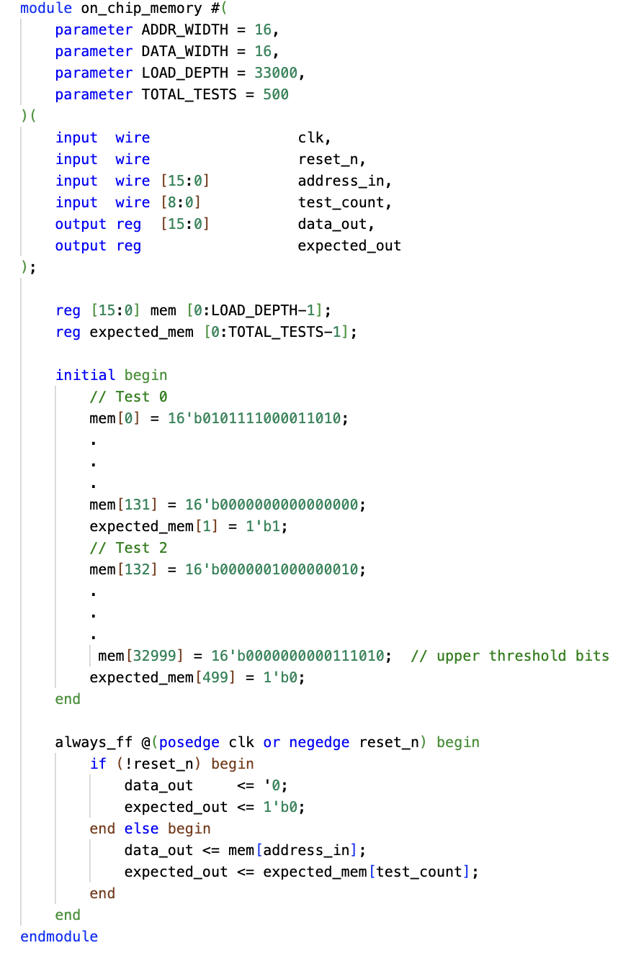
Figure 10 - on_chip_memory file

Managing Button Bounce in the Reset Mechanism

When using a physical push button, the mechanical contacts inside the button can cause a phenomenon called button bounce. This occurs because when the button is pressed or released, the contacts do not settle immediately. Instead, they can oscillate between an open and closed state for a few milliseconds. This bouncing effect causes the button's signal to transition multiple times between logical 0 and 1, potentially leading to unintended behaviors in digital circuits.
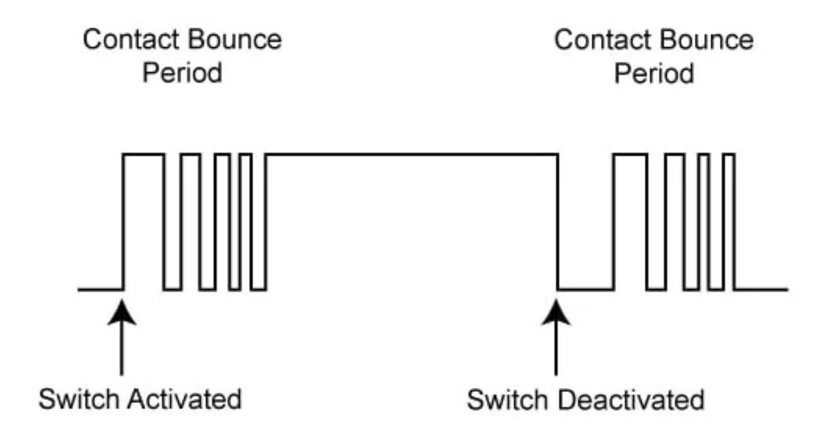

Figure 11 – Button Bounce for active high button

In our case, since the reset button is active-low and is used to reset the system, any unintended multiple transitions caused by bouncing could result in erratic or unintended resets. Similarly, when releasing the button, residual bouncing could result in the reset signal being incorrectly deactivated multiple times or too soon.

Debouncing Method: Using a Counter-Based Approach

To address the bouncing issue, we implemented a debouncing mechanism in the FPGA using a counter-based approach.
This ensures that the reset signal is only recognized as valid when it has been stable for a sufficient number of clock cycles.

Methodology:

1. Signal Stability Verification with a Counter
- The signal from the physical button is sampled on every clock cycle.
- A counter tracks how long the button signal remains unchanged.
- If the signal remains stable for a predefined number of clock cycles (e.g., corresponding to 10ms), it is considered valid.
- If the signal fluctuates before reaching the required duration, the counter resets, ensuring only a stable input is processed.

2. Stable Reset Activation and Deactivation
- When the button remains pressed (logical 0) for the full duration of the counter, the system recognizes a valid reset signal.
- When the button remains released (logical 1) for the full duration, the system registers that the reset has been deactivated.
- Any rapid fluctuations caused by bouncing are ignored, as only a signal that maintains stability over multiple clock cycles is considered valid.

How This Solves the Problem?
This debouncing method ensures:
Stable Reset Activation:
- The signal is activated only when the button has been consistently pressed (logical 0) for the required duration.
- This prevents false resets caused by transient bouncing during a press.
Stable Reset Deactivation:
- The signal is deactivated only when the button has been consistently released (logical 1) for the required duration.
- This prevents unintended state transitions caused by bouncing during release.
Noise Filtering:
- Any rapid fluctuations in the button signal due to mechanical bouncing are ignored.
- The counter ensures that only a signal that remains stable over multiple clock cycles is processed.

Post silicone

Hardware Setup for Post-Silicon Validation
To support smooth integration of the fabricated chip on the PCB, the design uses the QFP (Quad Flat Package) form factor. This package was selected due to its mechanical robustness, accessibility, and compatibility with standard surface-mount assembly processes. The QFP offers leads on all four sides of the package, which simplifies routing of I/O signals and power rails across multiple directions on the board.
The selected variant includes 44 leads with a 0.8 mm pitch, ensuring sufficient pin count for our data bus, control signals, and power interfaces, while maintaining a compact physical footprint. The exposed pad and grounded leads also help improve thermal performance and electrical stability during high-speed signal operation.
This packaging choice provides a practical balance between integration density and testability, making it well-suited for the post-silicon validation stage, where direct access to all signal lines is essential.

Pin Placement

The diagram below shows the final planned pin placement for the DUT
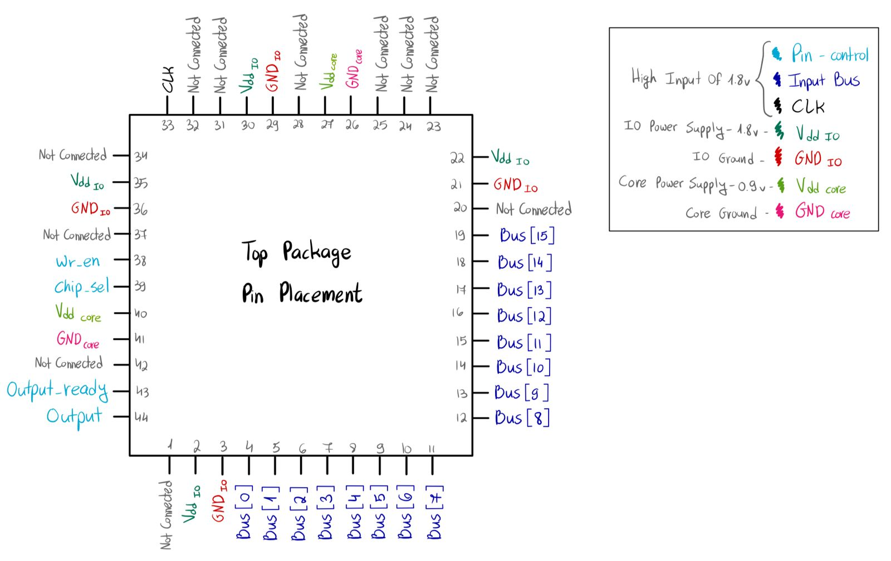
Figure 12 – Top package Pin Placement

Pinout Description
- Data I/O Bus signals (Bus[0] to Bus[15]) are placed consecutively along the bottom and right sides of the package to allow for compact and uniform routing of the 16-bit bus.
- Control signals such as wr_en, chip_sel, output_ready, and output are grouped on the left side to ensure clean timing alignment and simplified interface with the FPGA.
- The clock input (clk) is located at the top-left corner, isolated from data lines to minimize signal interference and jitter.
- Power domains are clearly separated for electrical stability:
  - VDD_IO (1.8V) and GND_IO provide power and ground for the I/O interface.
  - VDD_core (0.9V) and GND_core supply the internal logic of the chip.
- Several pins are intentionally marked as Not Connected, allowing layout flexibility and future expansion if needed.
This pin configuration was chosen to support clear signal organization, good power integrity, and ease of integration with the FPGA board and level shifter. It reflects the final layout constraints while preserving accessibility for debugging and measurement during post-silicon validation.

System-Level Schematic: DUT Integration and Power Routing

As part of the preparations for the post-silicon validation phase, that will take place next year, we created a schematic that illustrates the expected physical integration of the fabricated chip on the test board. This schematic serves as a clear communication tool between the FPGA validation team and the chip design team, showing how signals and supply voltages are routed to the DUT. The focus is on representing the signal flow and power delivery rather than detailed pin-level schematics.

The following figure presents a system-level schematic that outlines the physical wiring and voltage domains surrounding the DUT during post-silicon operation. It highlight component placement, power sourcing, and data path routing between the DUT, level shifters, and the external control interface.

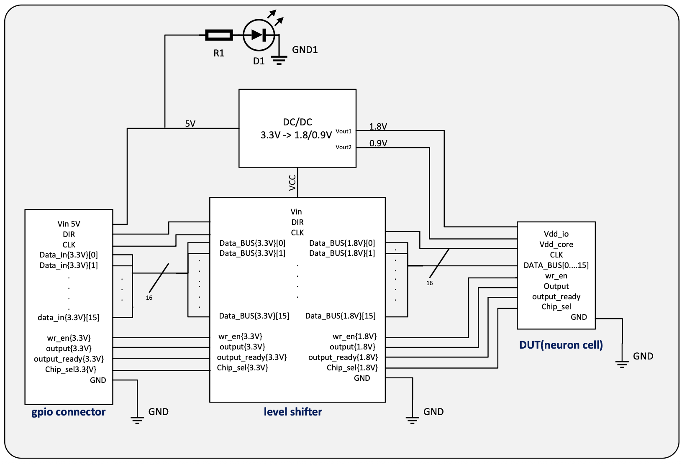
On the right side of the system is the DUT, which operates with two separate power domains: 1.8V (Vdd_io) for the I/O interface, and 0.9V (Vdd_core) for internal logic. The DUT receives a 16-bit wide Data_BUS, a CLK signal, and several control inputs including wr_en, and chip_sel. It also provides output signals such as output and output_ready.
Figure 13 – Dut integration and Power Routing
A level shifter, located at the center of the diagram, converts signals from the 3.3V logic domain (used by the FPGA and GPIO interface) down to the appropriate levels required by the DUT - 1.8V for I/O and 0.9V where necessary for internal logic interfacing. All bidirectional or output signals from the DUT also pass back through the level shifter to be compatible with the FPGA's 3.3V domain.
The DC/DC converter receives a 5V input and supplies two output rails: 1.8V for the DUT's I/O domain and 0.9V for the core logic. These are distributed to both the DUT and the level shifter.
On the left side, the GPIO connector serves as the interface with the FPGA. It delivers all incoming control signals, clock, and data lines at 3.3V logic level. These signals are routed through the level shifter to ensure compatibility with the lower-voltage DUT.

Appendix

Tasks to Be Completed-
- Verify that the system’s power consumption is indeed 5W.
- Check the board’s resource-utilization percentages.
- Fix timing constraints file.

